**Lab2: Quartus Example 1**

**CSCE2214 Digital Design Laboratory**

**Note: Please read each step in its entirety before proceeding.**

1. Create a directory/folder in your “Documents” folder named **Digital_Design_Labs**. Within that folder, create another folder named **Lab2**. Note: folder Lab2 is all one word!
2. Start Quartus II (64-bit). If the licensing error window pops up, please select “Specify a valid license…” and use the following as the license file: [**1800@csce-licsrv.ddns.uark.edu**](mailto:1800@csce-licsrv.ddns.uark.edu) **NOTE: if you change computers, you may need to perform step #2 again when using Quartus**
3. Click on File -> New Project Wizard -> Next
4. Click on the upper left “...” to browse. Select “Libraries” on the left side of the window, then select “Documents->Digital_Design_Labs->Lab2, then click Open. **Note: In future labs, you will want to create and select the appropriate Lab folder when specifying where you would like your design files to reside.**
5. For the Project name, enter: **NORgate** (project name is arbitrary). *Take note the name of your top-level entity defaults to the project name. You should make sure that your design files (block diagram, vhdl, and waveforms) are saved as the same name to avoid any potential errors.*   
   Click Next -> Next
6. For the Family select Cyclone II, under Available devices select **EP2C35F672C6** -> Finish.
7. Click on File -> New and select Block Diagram/Schematic File -> OK
8. Double click anywhere within the schematic, click on + next to the c:/alterra/91/quartus/libraries
9. Expand the **primitives** folder, then **logic**, double click on **NOR2**
10. Double click on the schematic, expand the **primitives** folder, then **pin**, double click on **input**
11. Repeat the previous step and add a second input pin to the schematic. Here is what it should look like so far:  
    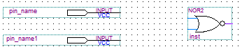
12. Double click on the schematic, expand the **primitives** folder, then **pin**, double click on **output**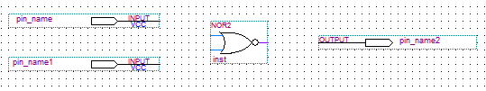
13. Connect the input pins/output pins (details below):
    1. Select the Orthogonal Node Tool from the toolbar on the left of the schematic window:  
       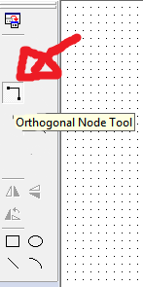
    2. Hover your cursor over the tip of the pins (here are the many possibilities in this schematic):  
       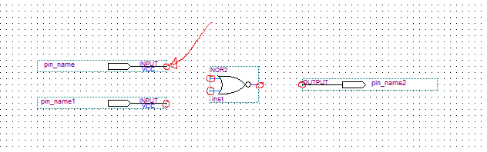
    3. Click, Drag/hold to connect the pin to wherever it needs connecting (another pin or even another wire). When you see a square box appear, you can release the mouse button as that indicates the wire is connected properly. Here is what your schematic should look like once connected (may differ very slightly):  
       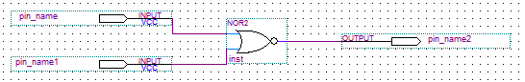
    4. Once done, press “Escape” on your keyboard (within Quartus) to return to the “Selection tool” or just click on the Selection tool icon within the left toolbar.
14. Rename the input and output pins:
    1. Double click on one of the two input pins on your schematic, and rename the pin to **PB1**
    2. Double click on the other input pin, and rename it to **PB2**.
    3. Double click on the output pin, and rename it to **LED**.
15. Select the “Text Tool” (**A**) on the left toolbar, and click on an area below your schematic to type your name. Once done, press “Escape” on your keyboard or click on the “Selection tool icon” within the left toolbar.
16. Click on File -> Save. This will save your block diagram. Please use the same name as your Top Level Entity (shown in the “Entity” window on the left hand side of Quartus). In this case, save your block diagram as NORgate within your project folder (Documents/Digital_Design_Labs/Lab2)
17. Click on Processing -> Compiler Tool -> Start. When it is finished click on OK. Disregard the warnings. If you get errors (resolve them and perform this step again):
    1. You may have named your Project/top-level entity something different than your schematic file.
    2. You did not wire up your pins correctly.
18. Click on Assignments -> Pins.
19. Right click on LED -> Node Properties, then choose **PIN_AE23**  as the location. Later, you will see the output (LED) on your schematic will match LED0 on the actual FPGA board.
20. Right click on PB1 -> Node Properties, then choose **PIN_N23**  as the location. Later, you will see the input (PB1) on your schematic will match KEY1 on the actual FPGA board.
21. Right click on PB2 -> Node Properties, then choose **PIN_P23**  as the location. Later, you will see the input (PB2) on your schematic will match KEY2 on the actual FPGA board.  
    The assignment window should look like this:  
    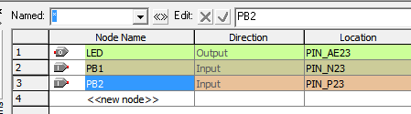
22. Close the Pin Planner Window.
23. Click on Processing -> Compiler Tools -> Start. When it is finished click on OK. Disregard the warnings. If you get errors (resolve them and perform this step again):
    1. Check that your Pin assignments are correct. Make sure output **LED** is mapped to **PIN_AE23**, and NOT PIN_A23
24. Grab an FPGA (Alterra DE2) board and plug it in, and turn it on:
    1. Plug the USB cable from the computer to the FPGA board. The FPGA board has several USB connections; make sure to plug the USB cable into the “BLASTER” port (Type-B USB port).
    2. Plug the power cable into the DC port.
    3. Turn on the FPGA board using the red-button near the DC port.
25. Click on Tools-> Programmer and make sure USB-Blaster is listed beside the Hardware Setup button and that the File //mydocs.uark.edu/………./NORgate.sof is listed.
    1. If the USB=Blaster is not listed beside the Hardware Setup button, click on the Hardware Setup button and select USB-Blaster **from the drop-down menu**.
    2. **If the //mydocs.uark.edu/………./NORgate.sof file is not listed, please refer back to step #2, and then #23**.
26. Make sure the Program/Configure box is checked then click Start.
27. Your FPGA has now been programmed. When both KEY1 and KEY2 are pressed, the output (LEDR0) should turn on (Note: You may need to press it firmly). Otherwise, the LED should remain off.  
    **NOTE: Make sure you discuss this behavior in your report and how it relates to a NOR truth table.**
28. Click on File -> Save Project.

Lab Report Notes:

Here are three things you may want to report on in your lab report. Feel free to include more information.

1. You should include your schematic picture in your report.
2. You should discuss your assignment of pins and why was this done.
3. You should talk about the schematic and how it relates to your results/programmed FPGA board. Use truth tables, and anything else to support your answer.